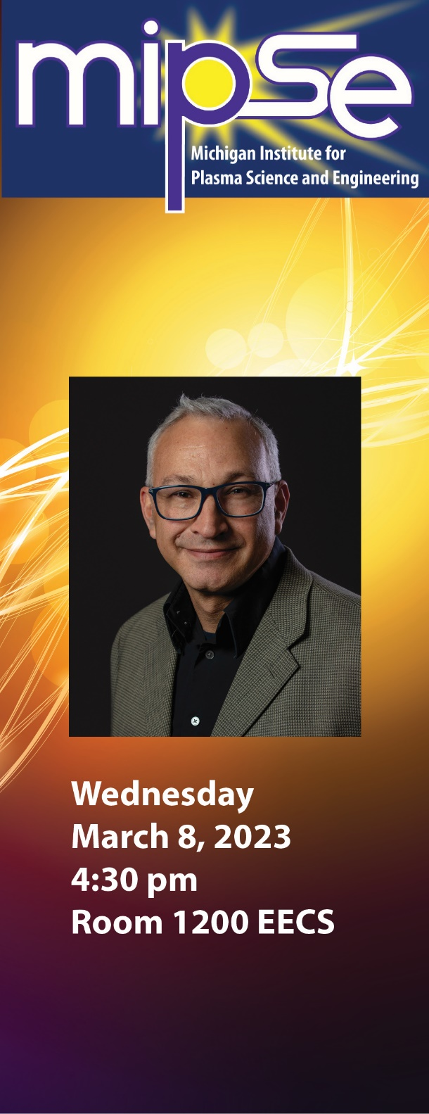 | Dr. Omar Hurricane  Lawrence Livermore National Laboratory  How Ignition and Target Gain > 1 Was Achieved in Inertial Fusion  For many decades the running joke in fusion research has been that `fusion’ is twenty years away and always will be. Yet, this year we find ourselves in a position where we can talk about the milestones of burning plasmas, fusion ignition, and target energy gain greater than unity in the past tense – a situation that is remarkable! In this talk, I tell the story of the applied physics challenges that needed to be overcome to achieve these milestones and the strategy our team followed. To help understand the story, several key physics principles of inertial fusion will be presented, and I will try and dispel any confusion about what the terms burning, ignition, and gain mean in the context of inertial fusion research.
About the Speaker: Omar Hurricane is Chief Scientist for the inertial confinement fusion program at Lawrence Livermore National Laboratory, a position he’s held since 2014. Omar completed his PhD in Physics at UCLA in 1994 where he remained as a postdoc doing plasma theory until 1998. In 2009, Omar was awarded the Department of Energy E.O. Lawrence Award for National Security and Nonproliferation for solving a long-standing nuclear weapons anomaly. More recently, Omar has been recognized for his contributions to inertial confinement fusion with Fellowship in the American Physical Society (APS), the 2021 Edward Teller Award of the American Nuclear Society, and the 2022 John Dawson Award from Excellence in Plasma Physics of the APS for achieving the first laboratory burning plasma.

