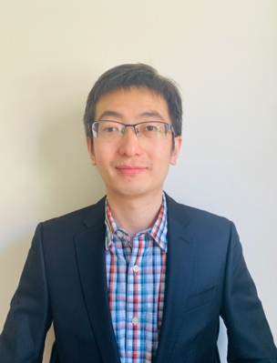

**Bin Liu**

*Ultrafast Dynamics in Light-Molecule Strongly Coupled Systems*

Friday, November 13, 2020

9:00 am

Host: Prof. Stephen Forrest

Dr. Liu works as a Postdoctoral Research Associate co-advised by Prof. Matthew Sfeir and Prof. Vinod Menon in the City University of New York since 2018. He received a B.S. degree and a M.S. degree in Physics from Shandong University in China, and received a Ph.D. degree in Physics from Case Western Reserve University in 2018.

**Abstract:**

Light-molecule strongly coupled systems provide a functional platform for useful optical devices with sophisticated designs via fine control of the optical properties of the constituent materials. The dynamics of these optical systems are of importance for both fundamental theoretic understanding and device applications. We have employed ultrafast pump-probe technique to investigate the dynamics of some strongly coupled systems with different organic materials. First, I will discuss the role of long-lived excitons in the dynamics of organic cavities filled with spin-conversion molecules. Next, I will talk about the transient optical response near polariton states due to ultrafast thermal modification of the cavity. Finally, the dynamics of SPP-exciton strongly coupled system is studied at different excitation conditions.

